Fractured Illusions Design Document
By Kiefer Smith

Table of Contents

- Introduction............................................................................2
- Gantt Chart…………………………………………………………………………...2
3. Project Role…………………………………………………………………………..3
4. Aims.......................................................................................3
5. Objectives..............................................................................3
6. Desired outcome....................................................................3
7. Research................................................................................4
7.1 4-5 Exemplar case studies.........................................4-5
7.2 3-4 References to background research....................5-7
8. Target audience.....................................................................7
9. Level Layout...........................................................................7
10. Site map...............................................................................8
11. Game Objective.....................................................................8
12. Game Mechanics...................................................................8
13. Game Tasks...........................................................................8
13.1 Goals....................................................................8
13.2 Rewards...............................................................8
13.3 Navigation............................................................9
13.4 Flow.....................................................................9
14. Moodboard............................................................................9
15. Use of audio..........................................................................10
16. Use of technology..................................................................10
17. Helpful Tutorials…………………………………………………………………..10
18. Bibliography…………………………………………………………………………11

1. Introduction

This project will be a first-person 3D horror level created within Unreal Engine 4 it won’t be made with Virtual Reality in mind. It will have horror elements such as sounds and triggers to create jump scares within such an isolated horror themed hospital environment. The level will be played by using a keyboard.
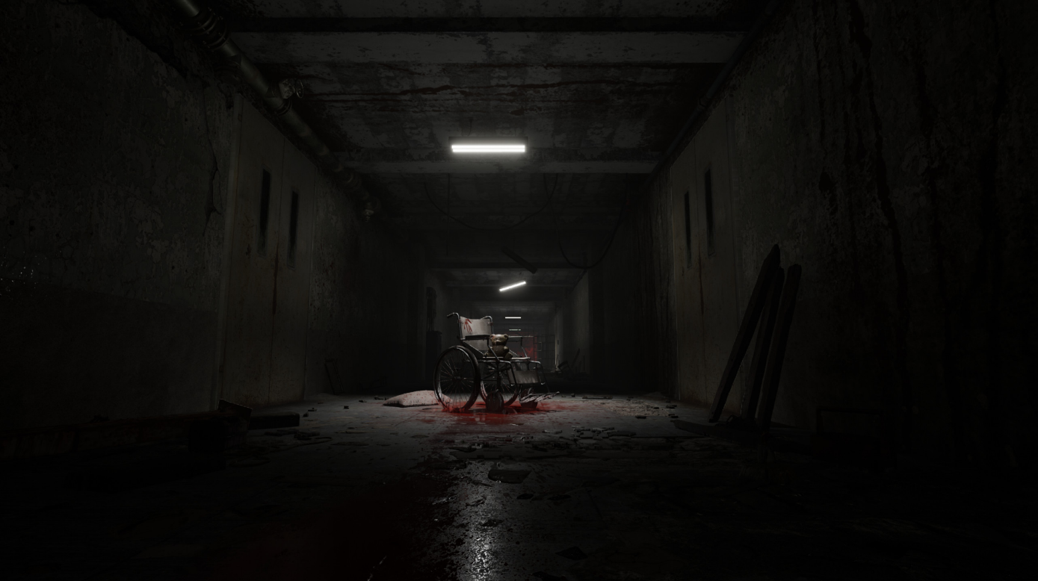

- Gantt Chart
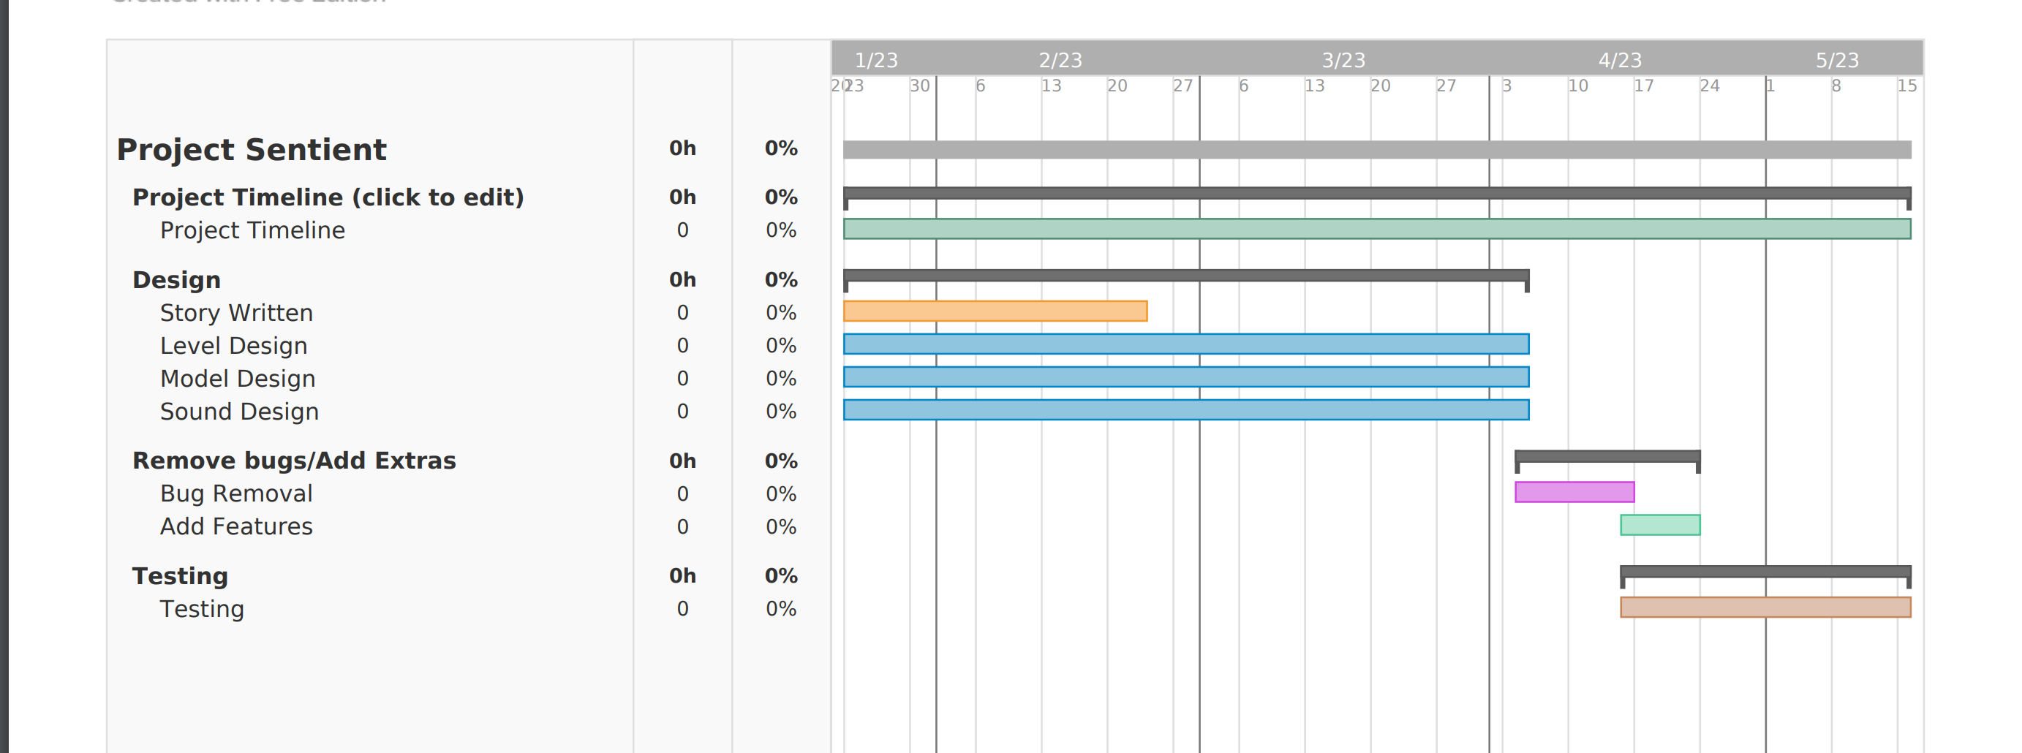

3. Project Role
The roles that will be covered in this project is:
- Project Management
- Graphic Design
- Sound Design
- Level Design
- UX/UI Design
Project management will cover the weekly tasks along with setting deadlines by using a Gantt Chart, for the graphic design this will be the creation of the assets within Maya3D, sound design will cover the sound of the environment and create the horror atmosphere of the level.
Level Design will cover the gameplay within the Unreal Engine level using blueprints to trigger an event such as doors slamming. UX/UI will work alongside the level design as the main and pause menu will be created in Unreal.
4. Aims
The aim of this project is to investigate and to create a horror level in Unreal Engine 4 with the intention of using best guidelines in frightening users.
5. Objectives
Objectives that will be undertaken for this project is
- To research similar horror related games such as Slenderman, Hotel Remorse, & Amber skull.
- Along with this, research will be carried out to discover what makes horror games so terrifying and successful.
- To create a level implemented using the research discovered.
6. Desired Outcome
The overall outcome of this entire project is to create a small horror level using the Unreal Engine 4 with the goal of terrifying the player.

7. Research
Below is a list of horror games I have looked at to use for inspiration and reference.
7.1 4-5 Exemplar Case Studies
Amberskull (Charlie Behan, 2018)
https://www.youtube.com/watch?v=s0OrSjwzE-Q&t=2s

Amberskull is a first-person indie horror game created by a lone developer within the game it focuses on the use of puzzles and avoiding the enemy on each level. Each level does its own approach to enemies and puzzles it builds tension and does jump scares which are timed well.

Hotel Remorse (Charlie Behan, 2015)
https://www.youtube.com/watch?v=We1SJg3Le0c

Hotel Remorse is a first-person indie horror game created by Charlie Behan this game focuses on the environment more so than enemies. The game implements the use of lighting and triggers where noises will play when the player enters the trigger it is does to scare the player such as having lights explode and creating darkness.

Slenderman (Mark. J Hadley, 2012)
https://www.youtube.com/watch?v=E9wBelF9d-o

Slenderman is a first-person indie horror game which has the player exploring a small forest and collecting pieces of paper which adds to a story. During the gameplay the player is followed by an entity called Slenderman. When he is close a noise triggers and a graphic pop up showing that he is close, this gives the player the feeling of unease as he can pop up anytime and encounter the player it builds tension as you cannot fight back. Your only choice is to flee or its game over.

Layers of Fear (Bloober Team, 2016)
https://www.youtube.com/watch?v=iTUq_FrjcWY

Layers of Fear is a first-person indie horror game which explores the use of sounds and the environment rather than fighting enemies. During the game you encounter puzzles in order to progress rather than fighting enemies if a room has creepy sounds with a shadow moving that is a telling not to enter the room as it will end the game.

The videos above are all horror themed games with them all having their own unique take on the horror genre. These games are popular due to the horror, and I am using these as inspiration for my own project.

7.2 3-4 References to background research

McAllister D.C, Stubbs, David (2015), Six Elements That Make For A Quality Survival Horror Game
Available at:
https://thefederalist.com/2015/03/03/six-elements-that-make-for-a-quality-survival-horror-game/
(Accessed 6-12-22)

According to The Federalist they listed six elements that make a good horror game. These are:

- Taking away the players power as they face any sort of danger by removing any weapons and a way to fight back this instils fear into the player. This brings out the horror as they have no choice but to flee and hide. This is known as disempowerment, this gives off the feeling of helplessness, vulnerability and being exposed.

- Another one is Isolation, since we are humans having no help or connection brings out the feeling of isolation, we find comfort in being with others being alone brings out pain and frustration for not being with others.

- Tension is listed as being needed as you need your player to feel that anything can jump out at you at any time.

- Uncertainty is another one as the player needs to feel uncertain about their fate whether they can escape or will remain trapped forever.

- Lingering Fear is another feature that is required as horror games leave an experience that is meant to stick with the player even after playing.

- Relatable Protagonist every horror game has to have a character that has to be underpowered with their own strengths and weaknesses.

Mitchell, Jared (no year) Creating Horror through Level Design
Available at: https://jaredemitchell.com/articles/creating-horror-through-level-design/
(Accessed 9-12-22)

- Jump Scares in horror games is often described as lazy but hard to pull off but they work if they are done well and in the right place.

- Chase Sequences are like jump scares but when timed well it creates tension for the player.

Rogers, Scott (2019) The Architecture of Fear: Level Design Lessons from Haunted Houses
Available at: https://www.nyfa.edu/student-resources/haunted-houses-game-design-nyfa/
(Accessed 6-12-22)

- Scott Rogers describes that horror has three S’s which are known as: Story, Scares & Spectacles. A story captures a player’s curiosity, Spectacles are described as amazing unforgettable moments within the game. Scale is described as the bigger the scare the better it is.

- Sound is described as being an ally as it unsettles the player, sound is used as foreshadowing that something is going to happen an example of this would be the music used in the Halloween movies.

- Limiting the field of view is used for making the player get really nervous when they can’t see what is coming up, the use of darkness and objects to obscure view gives the player that something could be around the next corner.

Martin, Geoffrey (2022) 12 Horror Games Set In A Hospital
Available at: https://www.thegamer.com/horror-games-set-hospital/#:~:text=Featuring%20a%20hospital%20in%20a,edge%20when%20venturing%20through%20them.

- Geoffrey explains that having a hospital in a horror game ups the scarcity of the setting as it brings much discomfort to people.

8. Target Audience
The target audience for this horror game is horror enthusiasts that are 18+. The horror genre has been studied and the outcome appeals mostly to the 18-25 age range.

Station12dev (2015) TARGET AUDIENCE
Available at: https://station12blog.wordpress.com/2015/10/16/target-audience/
(Accessed 10-12-22)

9. Level Layout (Rough idea)

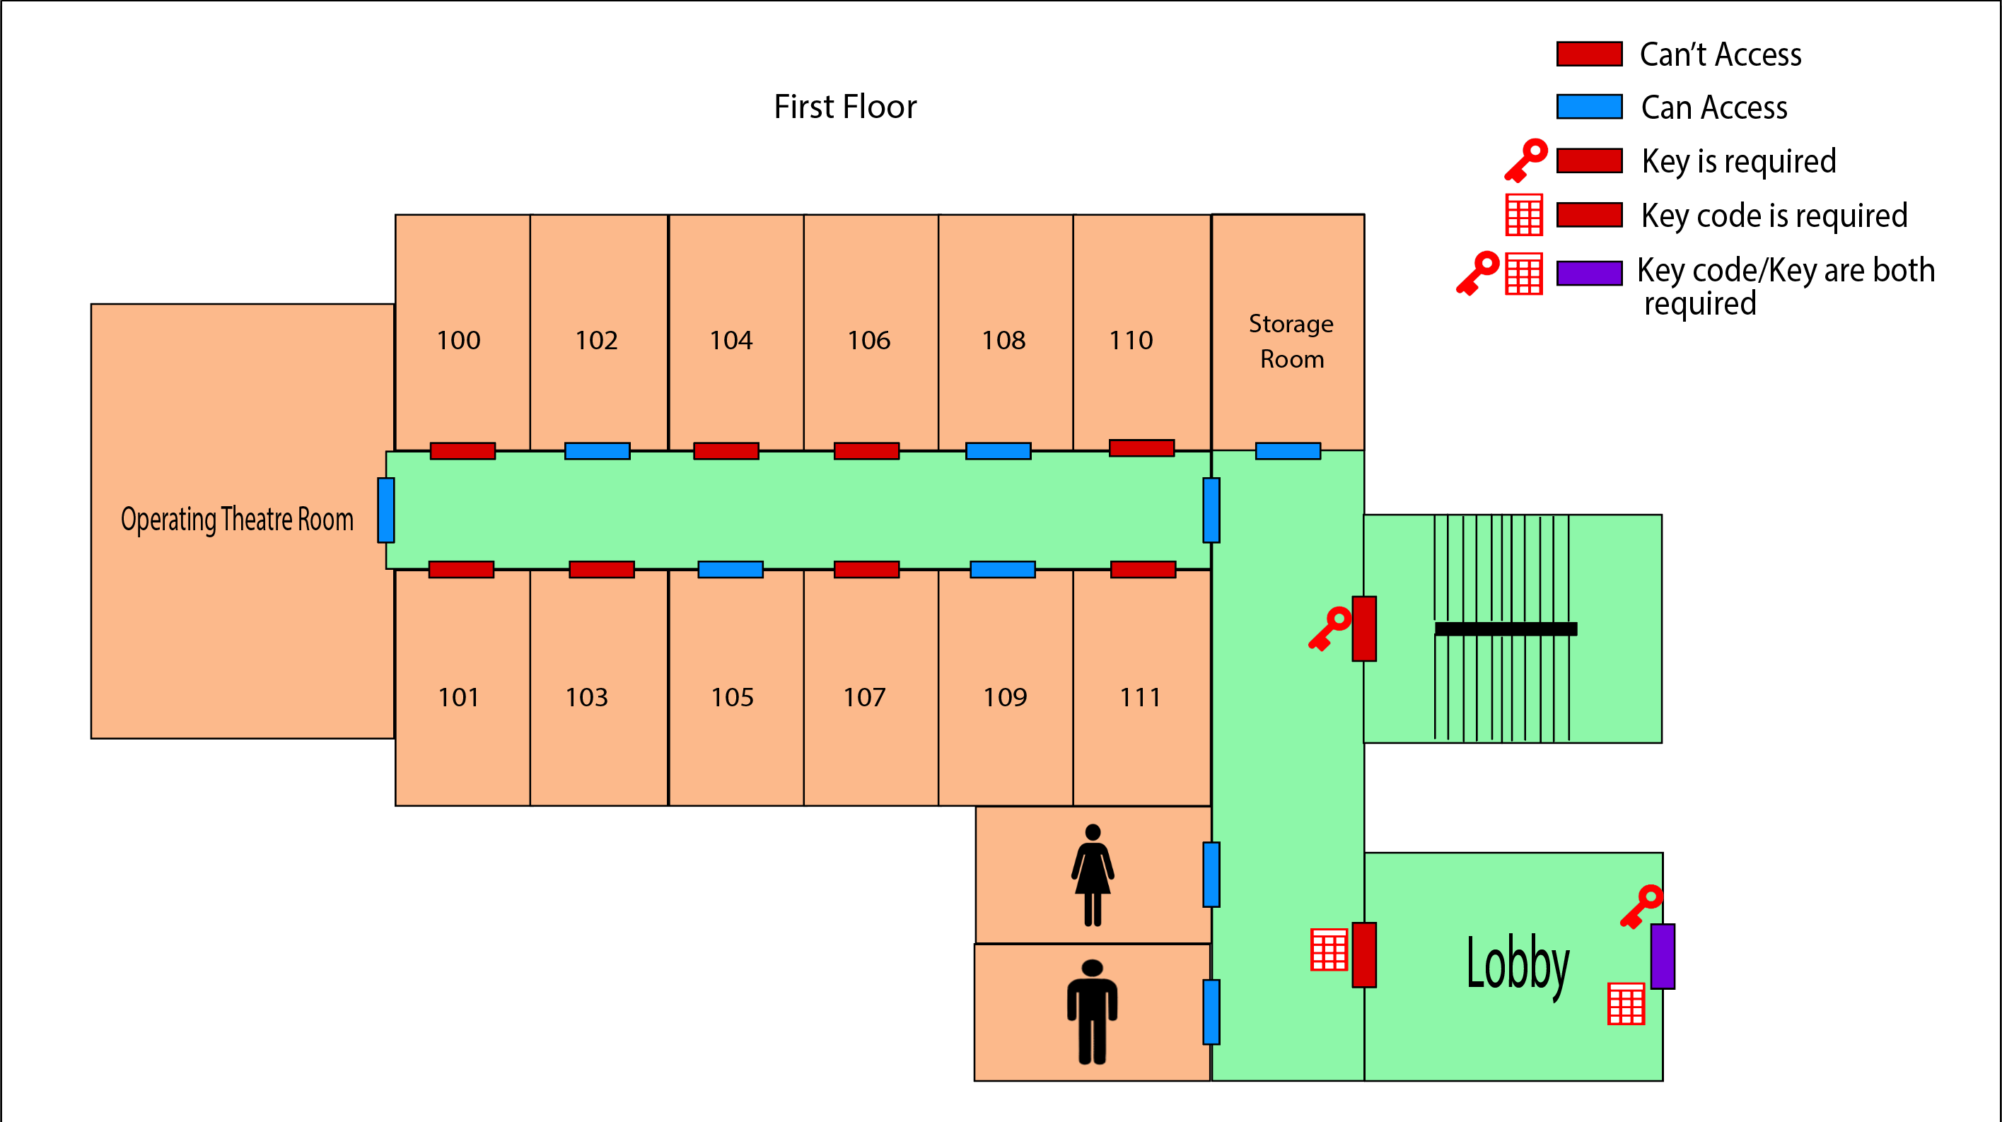

- Site Map
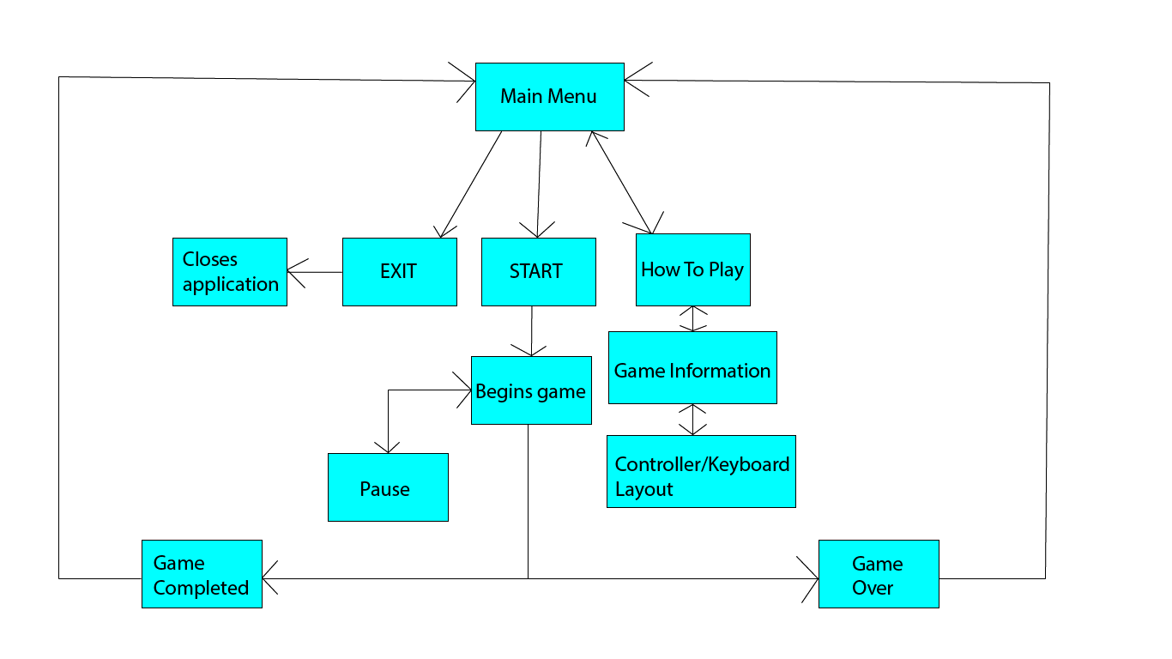

- Game Objective
The main objective of the game is for the player to escape a mental hospital using the correct keys/key codes to the corresponding doors.

- Game Mechanics
For the purposes of this game the player can interact with doors and furniture in order to recover the items around the level.

- Game Tasks
The main task for the player is to roam the building and listen for sounds of keys to collect it in order to escape.

  - Goals
The overall goal for the game is to escape an abandoned mental hospital. The player will need to find keys/key codes in order to open doors to progress further.

  - Rewards
Upon completion of the game the player will receive a message on screen thanking them for playing.

13.3 Navigation
Since the player is tasked with finding items they will explore a building, sound will help with navigation if the player is near an item a sound will play such as the sound of a key falling.

  - Flow
The player will start in an operation room in the building and work their way through hallways and rooms to look for the items around the level to escape.

- Moodboard

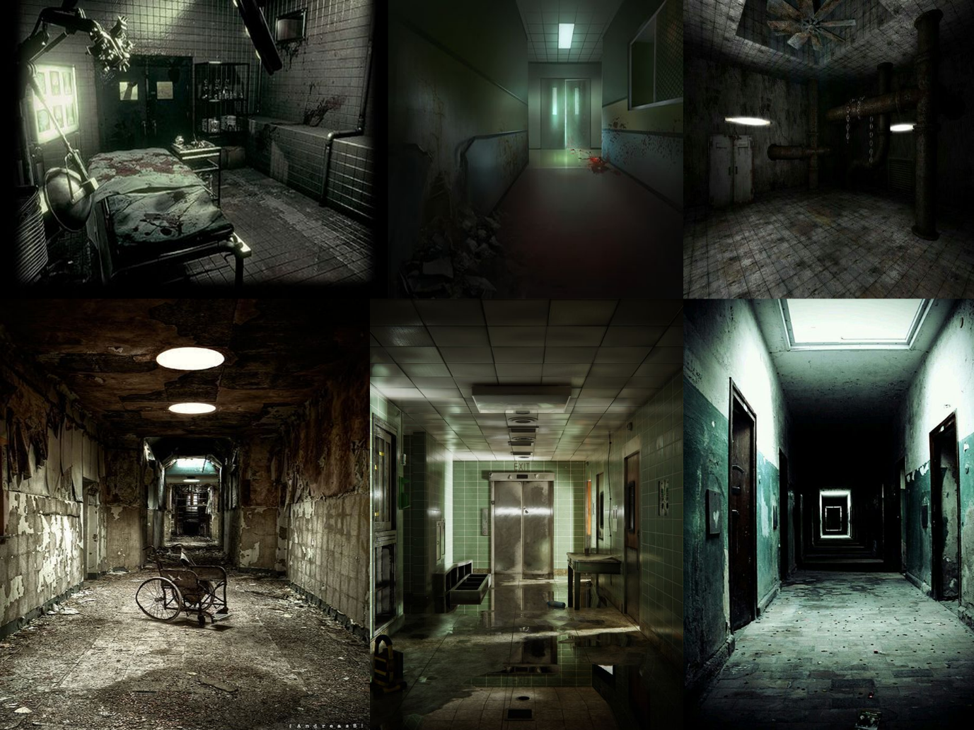

The moodboard is made up of images from Pinterest to show off the kind of atmosphere I am going for in my project. The game will be dark and have bits of lighting.

- Use of Audio

The types of audio I will be creating will be similar to the music below as music and sound is needed for this project to build the atmosphere and the suspense.

Drone Background Sound

https://www.youtube.com/watch?v=ZvtcbMv-zfo

Main Menu Sound

https://www.youtube.com/watch?v=6bcsXeuK8kk

Being Chased Sound

https://www.youtube.com/watch?v=ta7PPkwLZsg

- Use of Technology

The game will be created on the Unreal Engine 4. 3D assets will be made in Maya and the sounds will be made with the likes of Reaper. It will be made with PC in mind at FIS it will be on PC and can be played with a keyboard or game controller.

- Helpful Tutorials

https://www.youtube.com/watch?v=YSgLAb3Es-4

https://www.youtube.com/watch?v=Nb6obyNtUNU

https://www.youtube.com/watch?v=tKrBdxm4uxI

https://www.youtube.com/watch?v=Mi7r0LqUmOE

https://www.youtube.com/watch?v=Eakt2hBd3YY

Bibliography

McAllister D.C, Stubbs, David (2015), Six Elements That Make For A Quality Survival Horror Game
Available at:
https://thefederalist.com/2015/03/03/six-elements-that-make-for-a-quality-survival-horror-game/
(Accessed 6-12-22)

Mitchell, Jared (no year) Creating Horror through Level Design
Available at: https://jaredemitchell.com/articles/creating-horror-through-level-design/
(Accessed 9-12-22)

Martin, Geoffrey (2022) 12 Horror Games Set In A Hospital
Available at: https://www.thegamer.com/horror-games-set-hospital/#:~:text=Featuring%20a%20hospital%20in%20a,edge%20when%20venturing%20through%20them.
(Accessed 10-12-22)

Rogers, Scott (2019) The Architecture of Fear: Level Design Lessons from Haunted Houses
Available at: https://www.nyfa.edu/student-resources/haunted-houses-game-design-nyfa/
(Accessed 6-12-22)

Station12dev (2015) TARGET AUDIENCE
Available at: https://station12blog.wordpress.com/2015/10/16/target-audience/
(Accessed 10-12-22)

